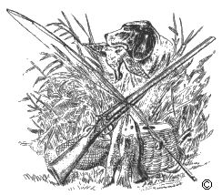

The Fitchburg Sportsmen’s Club
At Swallow Hill

WHERE: Fitchburg Sportsmen’s Club – 289 Rindge State Road - Ashburnham, MA 01430
WHEN: Saturday August 10th 2019 Sign in for event will begin at 8:00 am
AGENDA: 8:00 – 8:30 Sign in – light breakfast and coffee
8:30 – 11:00 Classroom Instruction
11:00 – 12:00 Lunch and Gun Display observation
12:00 – 3:30 Range
3:30 - 4:00 Wrap Up at Clubhouse
COST: $75.00 per participant. The event includes all ammunition, range safety equipment, light breakfast, lunch and refreshments.
NOTE: Registration fees will not be refundable in case of cancellation.
CONTACT: Fran Holder f-holder1@comcast.net
____________________________________________________________________________________________________________
REGISTRATION FORM
Name: _____________________________________________________________________________________________________
Address:___________________________________________________________________________________________________
Phone:__________________________________ Email:____________________________________________________________
Please mail payment to FSC PO Box 725 Ashburnham, MA 01430
Apply online at: www.fitchburgsportsmensclub.org

